**Tableau - Data Types**

The description of data types supported by Tableau is as follows:

|  |  |  |
| --- | --- | --- |
| **Data Type** | **Description** | **Example** |
| **STRING** | Any sequence of zero or more characters. They are enclosed within single quotes. The quote itself can be included in a string by writing it twice. | 'Hello'  'Quoted' 'quote' ‘12334’ |
| **NUMBER** | These are either integers (999) or floating (999.22) points. It is advised to round the floating point numbers while using them in calculations. | 3  142.58 |
| **BOOLEAN** | They are logical values. | TRUE  FALSE |
| **DATE & DATETIME** | Tableau recognizes dates in almost all formats. But in case we need to force tableau to recognize a string as date then we put a # sign before the data. | "02/01/2015"  "#3 March 1982" |

## ****Understanding Tableau****

Let us start by taking a look at the datatypes that Tableau supports. Refer to the diagram below which shows all the compatible data types of Tableau.

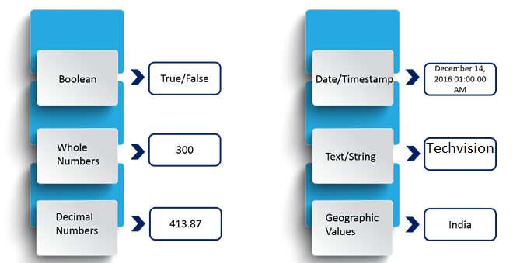

The above diagram shows you the data types that Tableau supports with  respective examples.

Now, the data types that we are dealing with can also be categorized broadly into two categories and they are:

* Measures
* Dimensions

Refer to the diagram below to understand the differences between Dimensions and Measures.  
